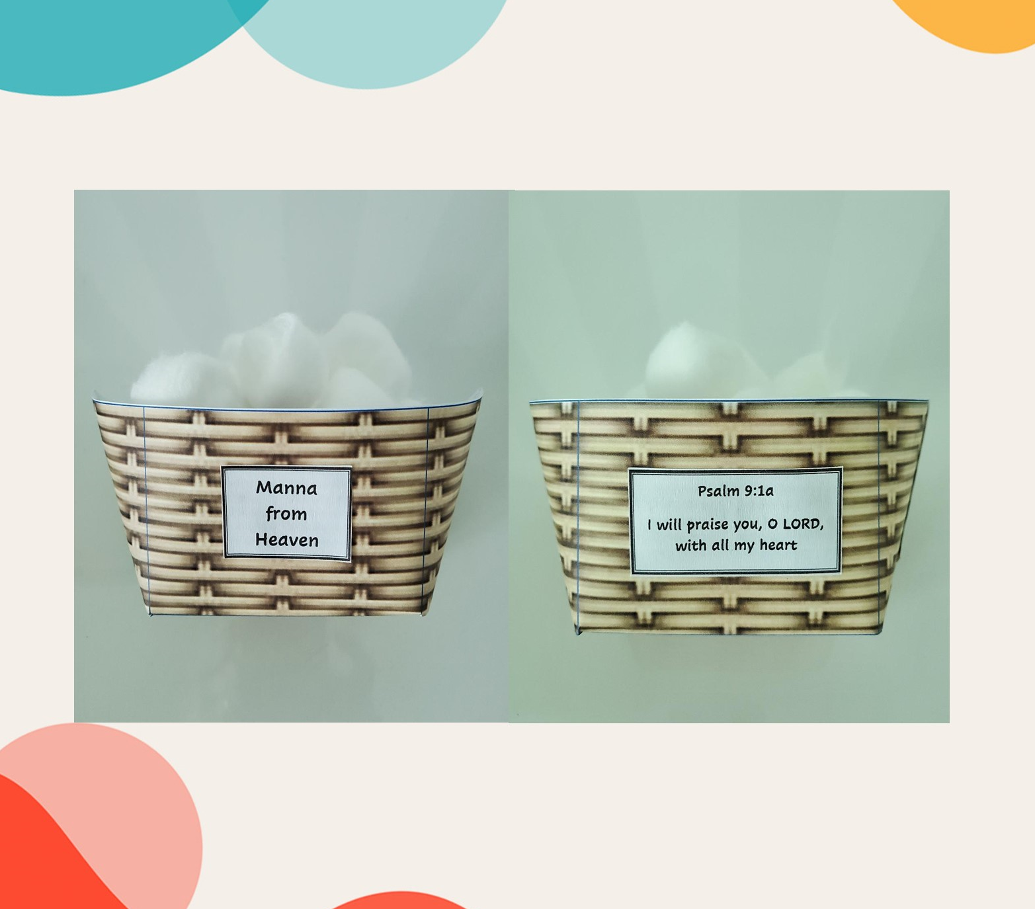

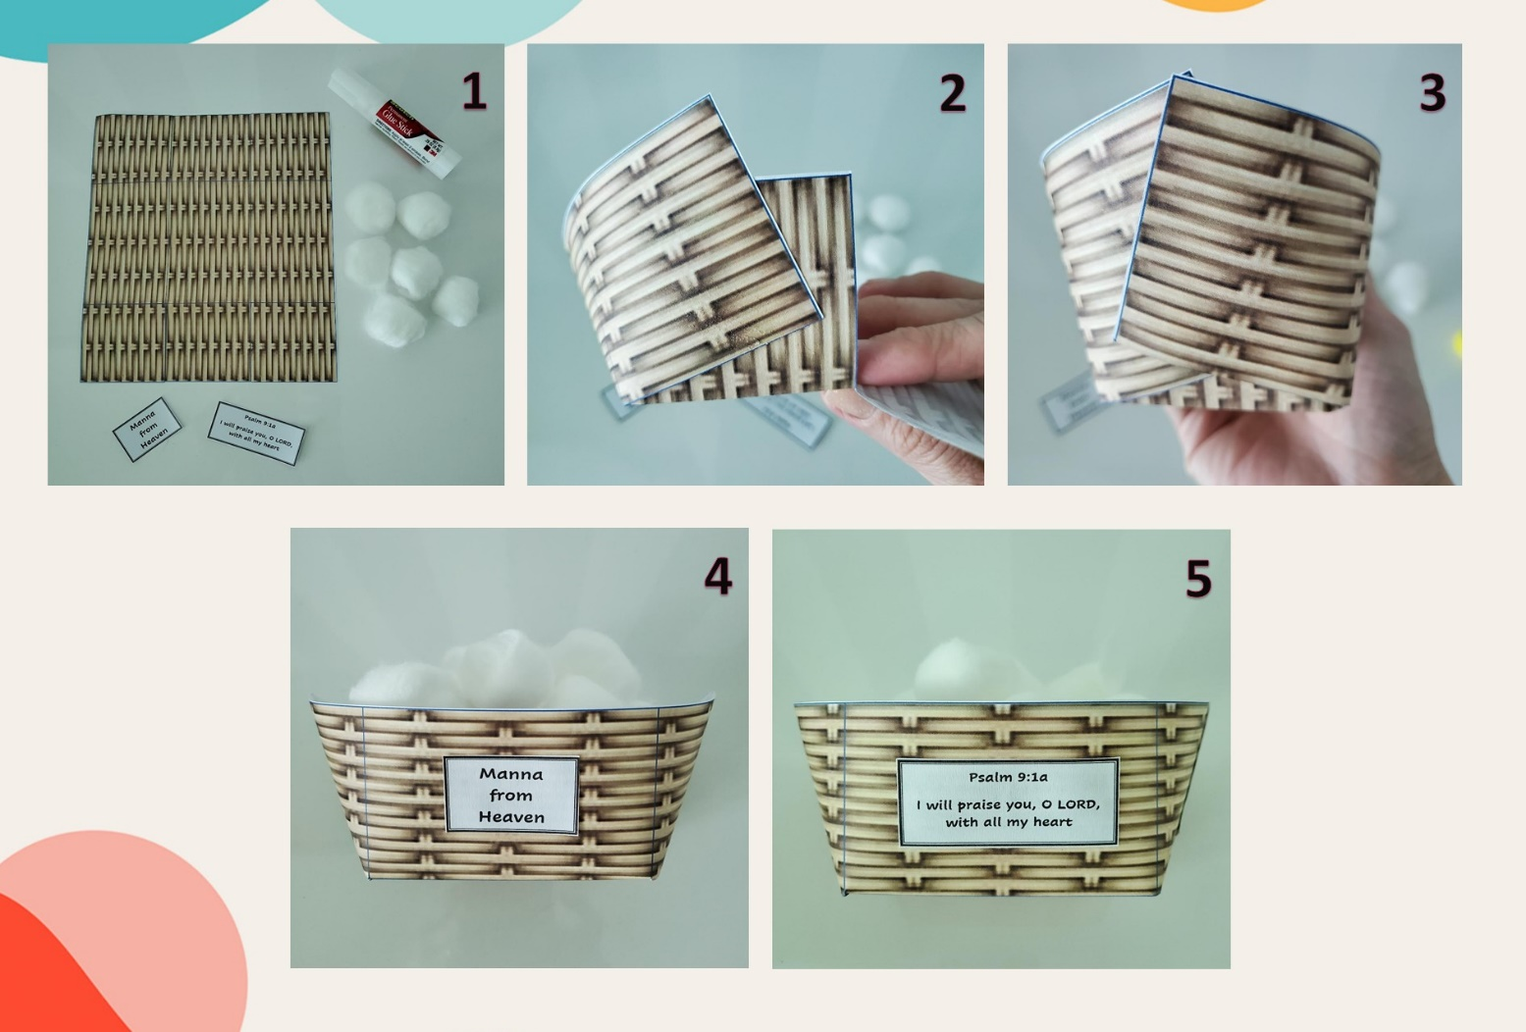

**Manna from Heaven**

**Psalm 9:1a**

**I will praise you, O LORD, with all my heart**



*Potong garis yang berwarna merah

**Manna from Heaven**

**Psalm 9:1a**

**I will praise you, O LORD, with all my heart**

*Potong garis yang berwarna merah