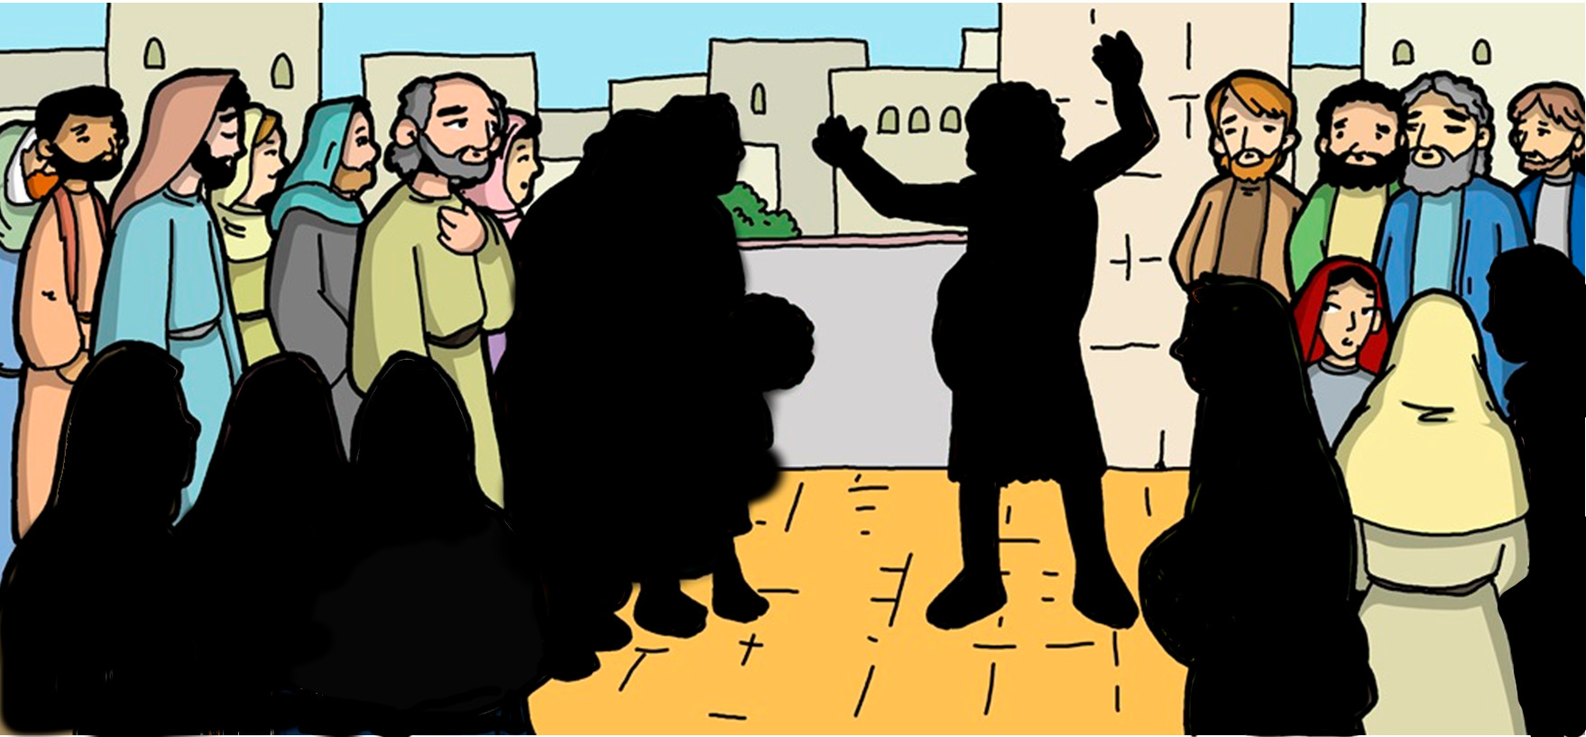

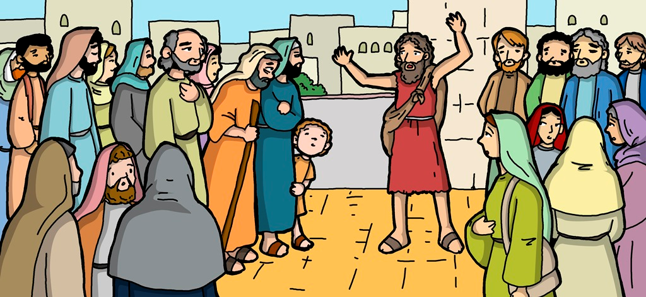





**Jonah 2:9**

**Salvation belongs to the Lord**

**Jonah Preaches at Nineveh**