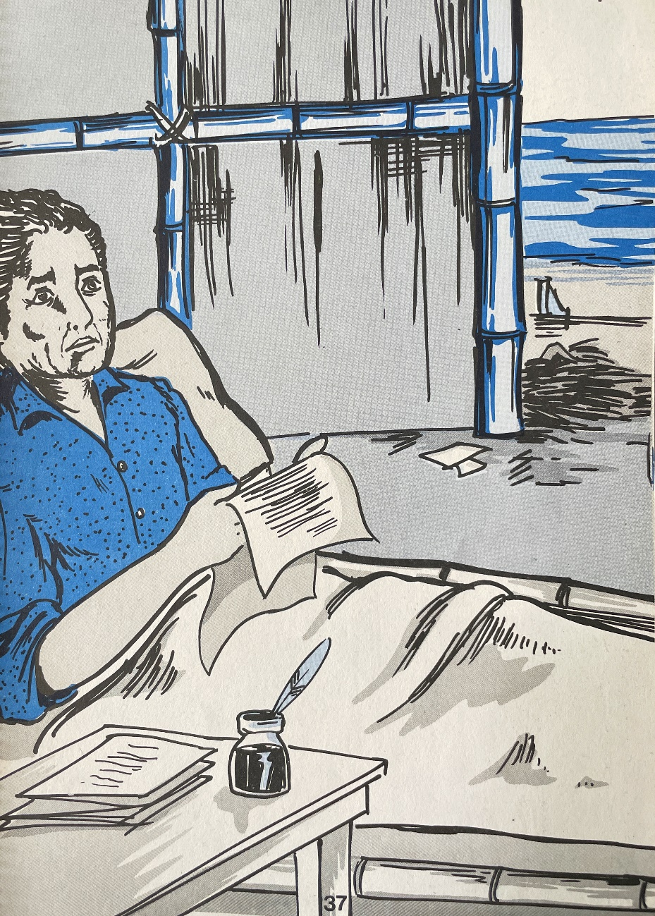

The King of Burma needed Adoniram’s help to translate letters from General Campbell. Adoniram remained faithful in the translation work, so that peace could be brought upon the Burmese people.

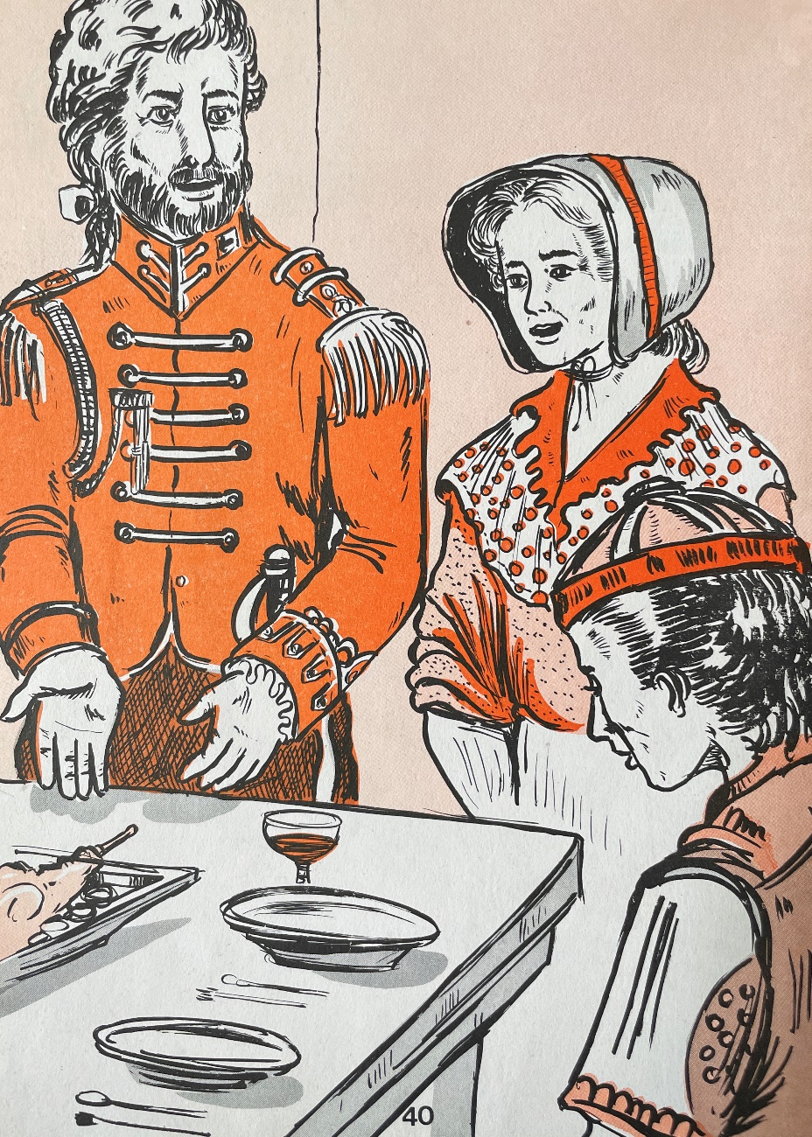

The Judson family was invited by General Campbell for a feast. Though some of the powerful people in Burma used to treat Adoniram and his family badly, Ann Judson still treated them with respect.

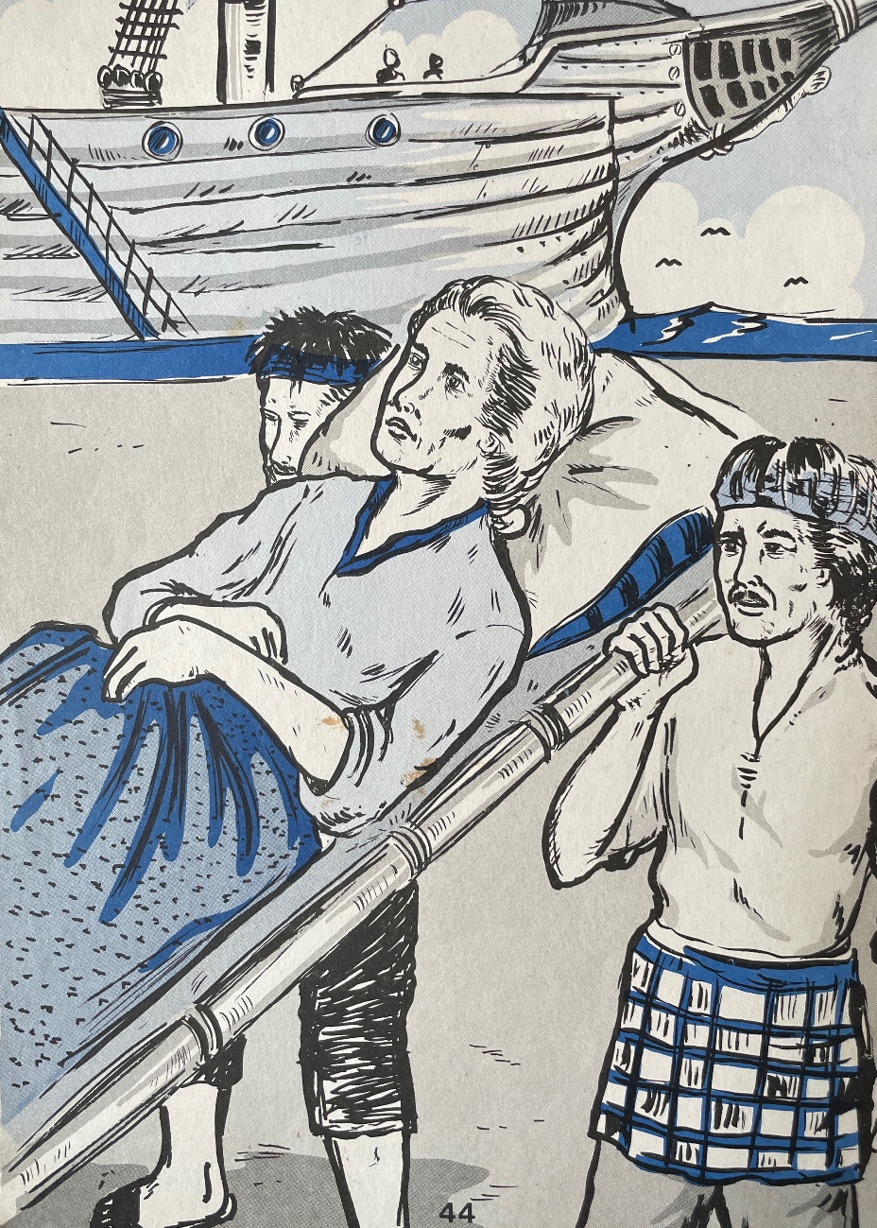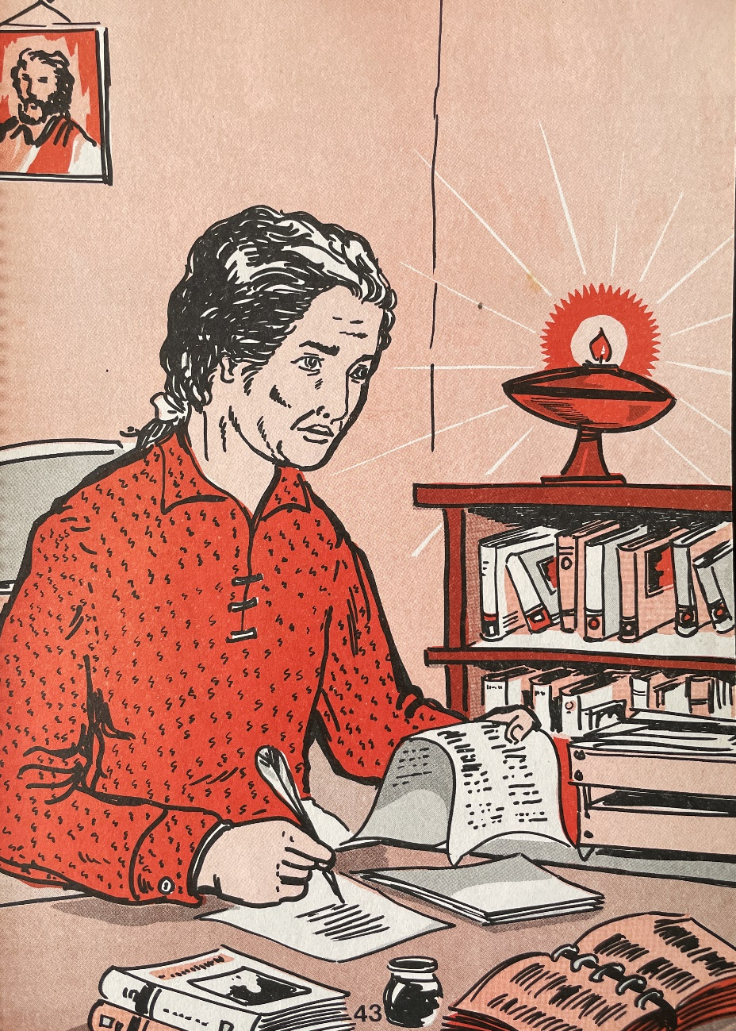

More Burmese people trusted and accepted Jesus as their personal savior. In April 1850, Adoniram fell very ill and eventually passed away. However, he is actually heading to the eternal “golden city”, the heaven to be with God.

Adoniram translated the entire content of the Bible into Burmese Language, so that more Burmese people will know about God’s word. He also created a book to help new missionaries who are coming to Burma.